API Security Risk Analysis

CIN: FIT/MAY26/CS8278
Subject: Cyber Security Lab
Website Tested: 1.https://requires.in/api/users?page=2
2.https://request.in/api/unknown/23

API Security Risk Analysis Report

1. Introduction
This project analyzes the security behavior of the ReqRes public API using Postman. The objective was to identify authentication mechanisms, error handling behavior, and possible API security risks.

2. API Information
API Name: ReqRes API
Base URL: https://reqres.in
Tool Used: Postman

3. Security Findings

Finding 1 – Authentication Security Implemented
The API requires API-key based authentication. Requests without proper authentication return HTTP 401 Unauthorized responses.
Observation | API blocks unauthorized requests
HTTP Status | 401 Unauthorized
Security Status | Authentication Control Present
Recommendation | Continue using API-key or token-based authentication

Finding 2 – Error Handling
The API returns proper error responses for invalid or unauthorized requests. No sensitive backend information was exposed in the response.
Observation | Proper error response handling detected
Impact | Prevents unnecessary information leakage
Recommendation | Continue secure error handling practices

Finding 3 – Rate Limiting Observation
Multiple repeated requests were tested through Postman. No visible rate limiting mechanism was detected during testing.
Observation | Repeated requests accepted
Potential Risk | Possible API abuse or excessive traffic
Recommendation | Implement request rate limiting

4. Tools Used
- Postman
- ReqRes API
- GitHub

API Testing Report

Objective
To test API functionality, authentication handling, error handling, and request validation using Postman.

1. API Success Test
The GET request was sent successfully to the API endpoint using Postman. The API responded correctly and verified endpoint accessibility.
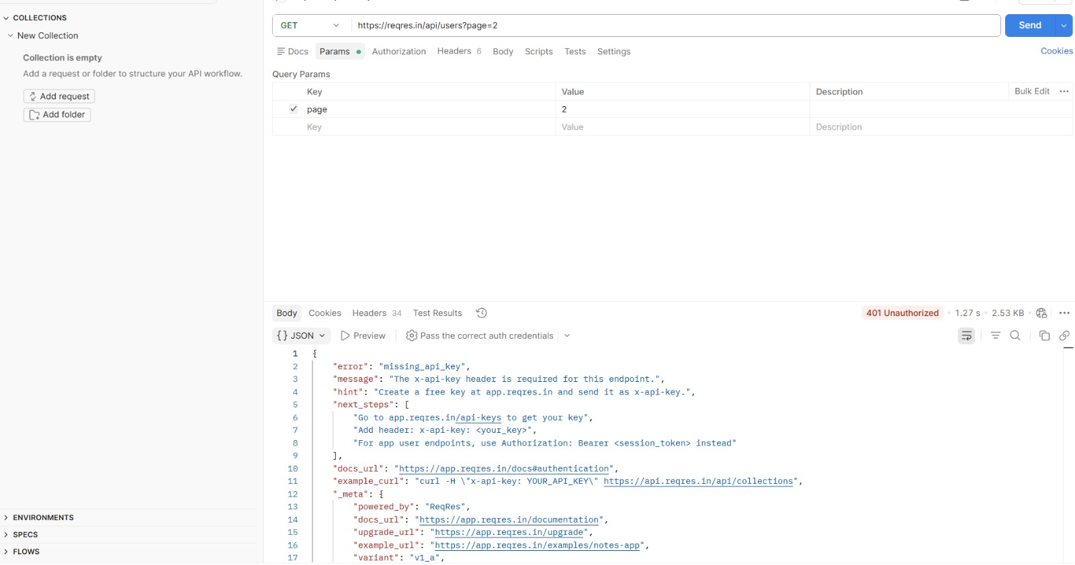

2. Authentication Requested

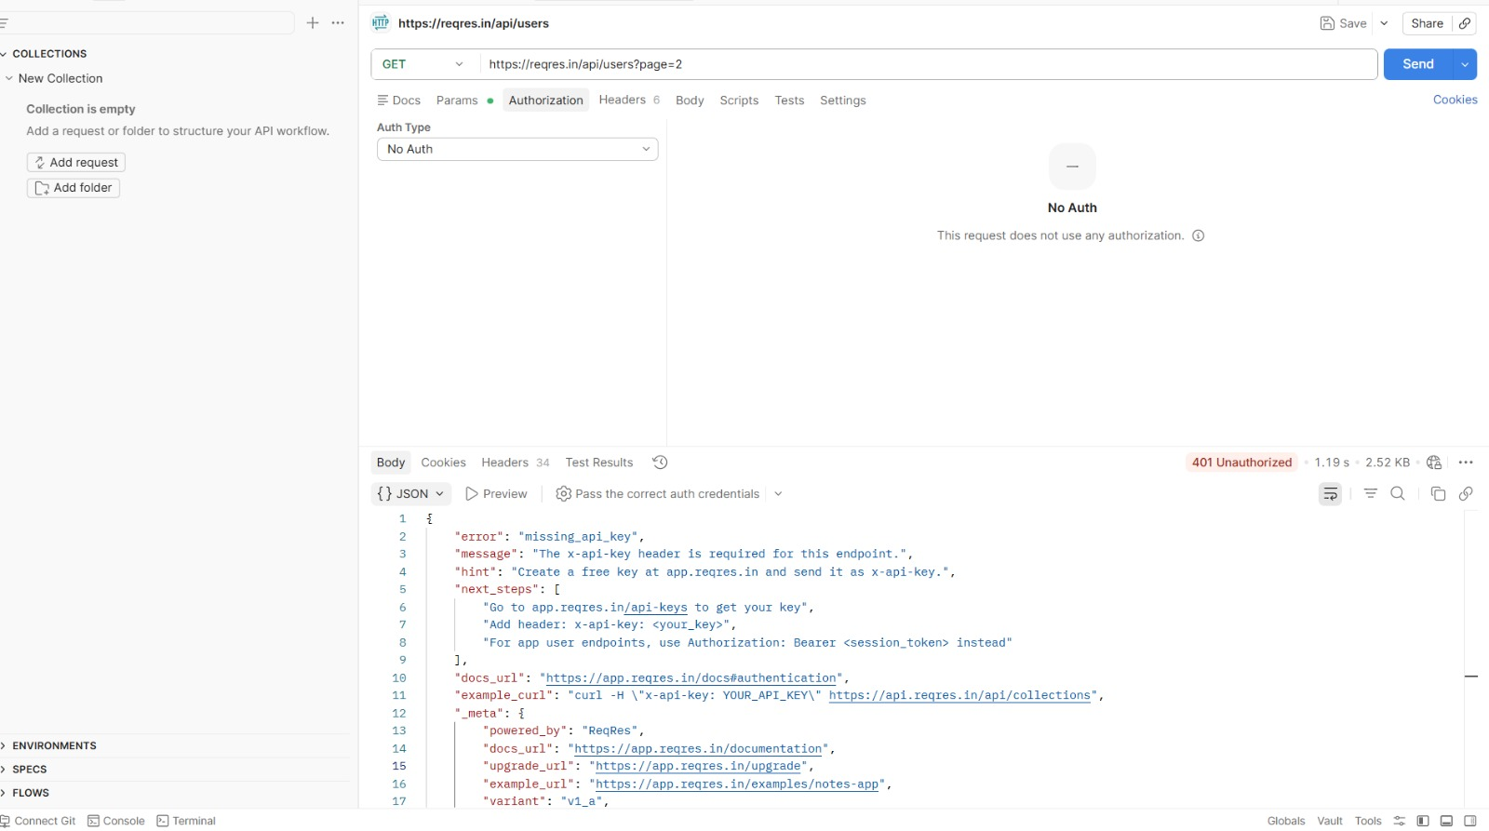
The API required authentication using the x-api-key header. Since the key was missing, the server returned HTTP 401 Unauthorized.

3. Error Handling Test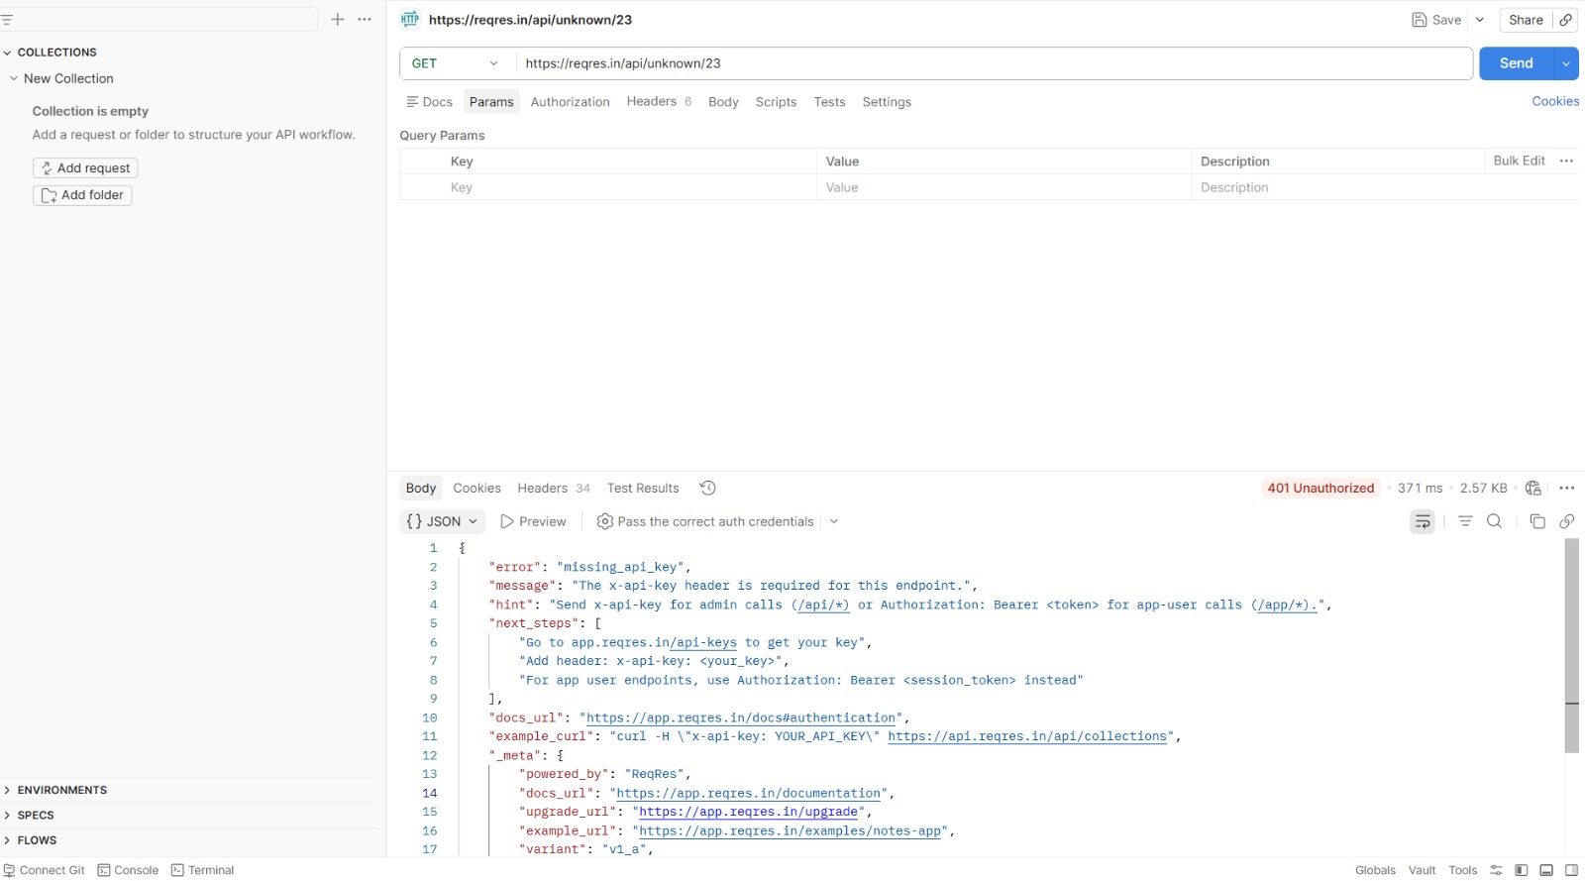
An invalid endpoint was tested to check API error handling. The server returned a proper structured error response with status code 401.

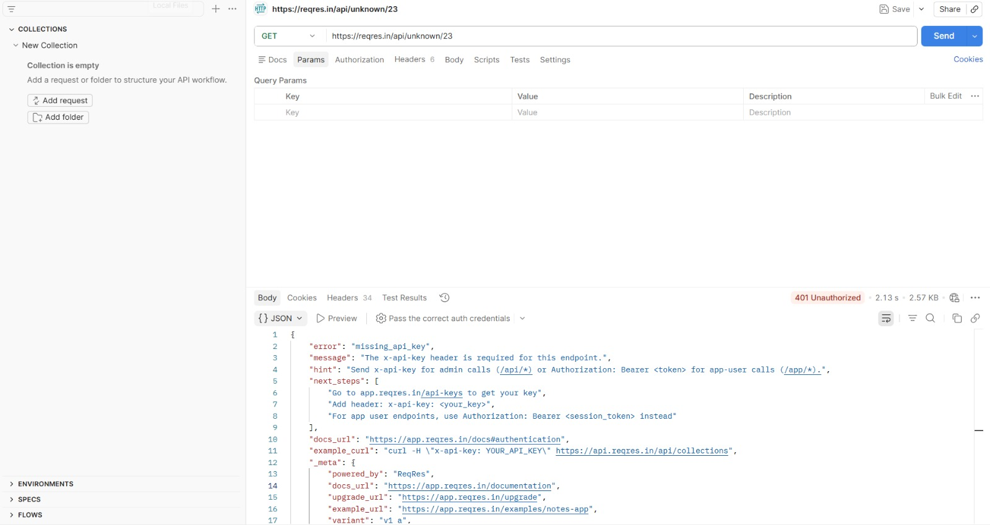

4. Rate Limit Test
Multiple requests were tested to observe API behavior. The server consistently validated authentication before processing requests.

Conclusion

5. Conclusion
The API demonstrated secure authentication mechanisms by blocking unauthorized requests using API-key validation. Proper error handling was also observed. However, visible rate limiting was not detected during testing. Overall, the API follows important security practices for access control.

The API testing confirmed that the server properly enforced authentication, handled invalid requests securely, and returned structured responses during all tests.

